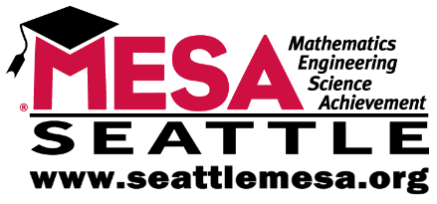
Resources
*Campus visits are free and open to everyone
*Look up the schedule and see when you and your family are able to attend
*Register for campus visit ahead of time (at least 3 weeks beforehand)
*Make a list of questions you might have about the college you are visiting

University of Washington- Seattle
http://admit.washington.edu/Visit/FroshInfoSessionTour
- Freshman Information Session + Campus Tour
- Sample a Class
- Transfer Thursday

University of Washington- Bothell
http://www.bothell.washington.edu/admissions/firstyear/visit
- Campus Visits
- Prospective Transfer Students
- Prospective First Year Entry Nursing Students
- Events:
- Preview Day- High School Juniors and Seniors
- Transfer Admission Workshop- Prospective Transfer Students
- Senior Application Day

University of Washington- Tacoma
http://www.tacoma.uw.edu/uwt/admissions/visit-campus
- Campus Tour
- Meet with an admission advisor
- Group Visits

Seattle University
http://www.seattleu.edu/visit/campus_tours/
- Campus Tours
- Class visits and faculty one-on-ones
- Group Visits

Western Washington University- Bellingham
https://admissions.wwu.edu/visit/tour
- Campus Tour
- On-call advising
- Meet with academic departments and campus offices

Community Colleges

Seattle Central Community College
http://seattlecentral.edu/outreach/visit-central.php
- Campus Tours
- Information Sessions

North Seattle Community College
https://northseattle.edu/tour-north
- Individual Tours
- Group Tours

Events
Fall Conferences for Latin@, African American, Native American, Pacific Islander, and Southeast Asian communities.
http://depts.washington.edu/reach/events-and-programs/fall-conferences/
__________________

Preview Day, Transfer Admission Workshop, Senior Application Day, Engineering Mentor Night, College Awareness, and conferences for Pacific Islander, African American, Latin@, and American Indian communities.
http://www.bothell.washington.edu/admissions/visit/events

__________________

Freshman Preview Day
http://www.tacoma.uw.edu/uwt/freshman-preview

Explore! Transfer to UWT
http://www.tacoma.uw.edu/uwt/admissions/explore-transfer-events
__________________

College Planning Day
Fall Preview Days
https://www.seattleu.edu/undergraduate-admissions/visit/events/
__________________

Discovery and Transfer Days
https://admissions.wwu.edu/visit/discovery-and-transfer-days

South Seattle Community College
http://www.southseattle.edu/campus-information/campus-tours.aspx
- Individual Visits
- Group Tours
- Culinary Arts Department Orientation

Shoreline Community College
http://www.shoreline.edu/enrollment-services/campus-tour.aspx
- Campus Tours

