

**MESA USA**

**NATIONAL ENGINEERING DESIGN COMPETITION**

**2016-2017**

**Prosthetic Arm Challenge 2.1**

**RESOURCE DOCUMENT**

This document provides critical information to assist teams in successfully meeting all competition requirements, including detailed descriptions and examples of various required elements.

Contents

Itemized Budget Sheet Sample 2

Budget Documentation Examples 3

Technical Paper 4

Academic Poster Presentation 7

Poster Required Elements 7

Presentation Required Elements 8

Isometric & Orthographic Drawing Samples 10

Block Diagram Sample 11

Pseudocode Samples 12

Specification Question Process & State Contacts 13

 2016-2017 MESA USA

National Engineering Design Competition

Prosthetic Arm Challenge 2.1

**RESOURCE DOCUMENT**

**ITEMIZED BUDGET SHEET SAMPLE\***

MESA Center: MESA School:

Level: MS HS Advisor/Teacher:

Student Team:

|  |  |  |  |  |  |  |  |
| --- | --- | --- | --- | --- | --- | --- | --- |
| Part | **Unit Dimensions** | **Retail Price** | **Price per Unit** | **Quantity Used** | **Total Cost** | **Retail Source** | **Receipt** |
| *6061 Aluminum flat*  *(example)* | *1/8” x 1/2” x 24”* | *$1.98/flat* | *$0.0825/inch* | *10 inches* | *$.0.82* | *Metalsdepot.com* | **1** |
| *Masking Tape (example)* | *1 inch x 60 yards* | *$4.02* | *$0.0019/inch* | *12 inches* | *$0.02* | *TheSupplyTree.com* | **2** |
|  |  |  |  |  |  |  |  |
|  |  |  |  |  |  |  |  |
|  |  |  |  |  |  |  |  |
|  |  |  |  |  |  |  |  |
| **TOTAL COST** | | | | |  | | |

**\*** A spreadsheet that will automatically calculate the budget has been created and is available for teams to use. Contact your state representative or visit the MESA USA website for a copy.

MESAUSA.ORG 2

 2016-2017 MESA USA

National Engineering Design Competition

Prosthetic Arm Challenge 2.1

**RESOURCE DOCUMENT**

**BUDGET DOCUMENTATION EXAMPLES**

The follows are samples of the types of documentation that would be acceptable to attach to your itemized budget sheet.

Please make sure that receipts are numbered and numbers are listed and matched with items on the budget sheet. (see last column of the example on the previous page and on the budget spreadsheet)

Printed Store Receipt Printed page from National Retailer Website

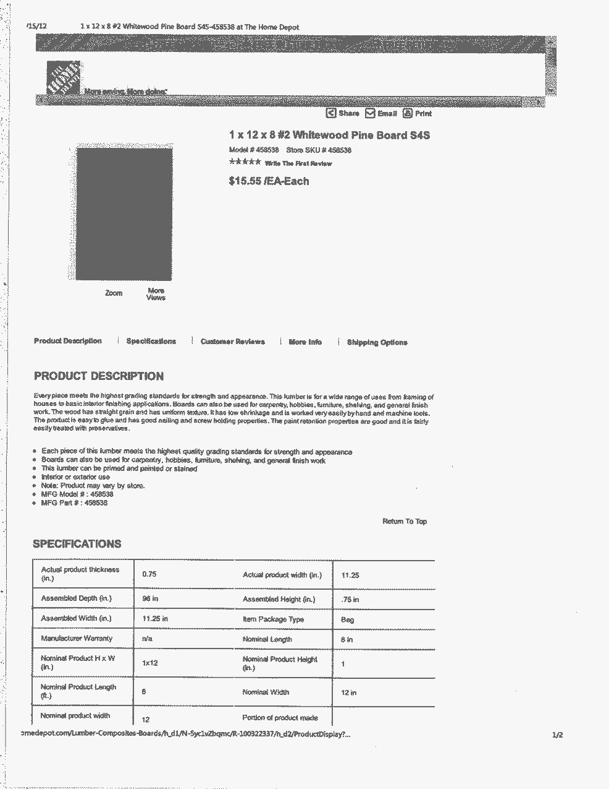

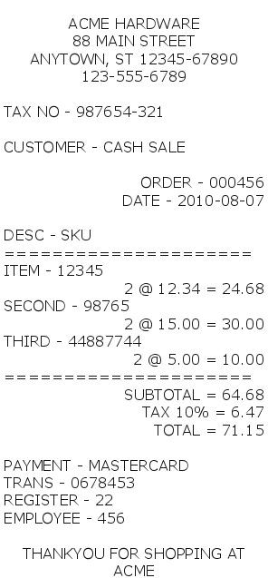

MESAUSA.ORG 3

**TECHNICAL PAPER**

**Using Your Engineering Design Notebook as a Foundation for Your Paper**

Everything you do to prepare for this competition – be it your design brainstorming, your sketching of possible approaches, your informal and formal research, your exploration of the MESA USA Curriculum, your building of various prototypes, your testing of each material, modification, or new model, or even your gathering and analysis of the data – everything you do to prepare your final design prototype is part of your engineering design process.

Like most STEM professionals, you will be keeping a notebook to make notes of everything you explore. From Day 1 – you will be using your notebook to tracks your ideas, your progress, your letdowns, your innovations, your interviews, your drawings and your data. If your team remembers, during each time you meet, open up your team’s notebook(s) and document everything – even your goofiest ideas and your worst drawings or testing results – then when it comes time to write your paper, you should have most everything you need in that notebook to write a strong technical paper.

**Contents** (Detailed description of each key section is as follows):

**A. Title Page**

Title, Authors, MESA State, School and Date need to be included.

**B. Abstract**

This section is an engaging, brief synopsis of your project (200-250 works). It should be written using minimal technical terms. It should paraphrase the design problem and team motivation, and should clearly summarize your design’s key features, results and conclusions. A person reading the abstract should be able to understand the contents of your entire paper in the 30 seconds it takes to read it.

**C. Table of Contents**

Your table of contents should correctly identify each required component of the paper.

**D. Introduction**

This section aims to engage readers while preparing them for the discussion that follows – *before* introducing any technical data or definitions, unless they are necessary. It is broken down into three sections which provide, in your own words, a clearer sense of your team’s design purpose, the design problem, and any background information. Each section should average one to two paragraphs each:

1. *Purpose.* In your own words, provide a compelling overview of your team’s design purpose or motivation (e.g., to solve a problem, to address a particular need, to evaluate or introduce a new concept etc.). This should expand upon what you shared in the Abstract.
2. *Scope*. Provide a clear restatement, in your own words, of the design problem including success criteria, limiting factors/constraints, and key variables to consider. After overviewing the design problem, make sure to overview your investigation approach and your design method.
3. *Background* Information. Present facts the reader should know, conditions or events prior to the project and any details of previous reports. This should include your review of other investigators/designers, as well as any of your related design objectives or hypotheses.

**E. Discussion of Design Process**

This is the longest section of the paper. It presents and thoroughly discusses all key evidence from your engineering design process and findings. As you explain these findings, make sure to include the right kind of compelling graphics to help readers better visualize your data or information (e.g. data tables/graphs or other figures/charts). These graphics, while they are referred to and explained here, should be located only in the appendix. As you explain your process and points, make sure to refer to the appropriate graphic within the paragraph in which it first becomes relevant.

1. Discuss your team’s design process, including:
   * 1. *Process Overview.* Clearly overview your team’s design process.
   1. *Roles.* Explain the roles of each team member at all stages of design.
   2. *Self-assessment.* Detail the nature and efficacy of each stage of your design process (including brainstorming, research, etc.)
   3. *Discussion of electronics hardware integration.* Detail the integration of the electronic hardware components into your prosthesis. Discussion should include breakthroughs, challenges and compromises made to integrate these components.
   4. *Discussion of Software development.* Clearly describe the development of the code used to control the electronic components. A pseudocode description of your coding logic should be included in the appendix (See samples on page 12).
   5. *Rationale for Design Choices.* Clearly explain what aspects of your design process (including brainstorming, research, design selections, modifications, testing, etc.) most informed all of your major design choices. Be specific. What part of your process most impacted your choices and how?
2. Briefly summarize any particular STEM (Science, Technology, Engineering and Math) concepts that most informed your team’s design process.
   1. *Math/Physics/Science Concepts.* Teams are encouraged to examine and report on relevant concepts relating to mathematics, physics or science. We encourage teams to visit the MESA USA Curriculum for this competition (at [www.mesausa.org](http://www.mesausa.org)) as part of your investigation.
   2. ***NOTE:*** Please also clarify if your team explored ANY advanced concepts, techniques, algorithms or other materials that would not normally be included in middle or high school subjects. The paper must reflect the team’s comprehension and capacity to explain such concepts. If these ideas were incorporated based on suggestions by people you sought out in your research, by volunteer STEM professionals at your school, or through other advanced text or web resources, make sure to also briefly reference this either here or in the Appendix.
   3. *Engineering/Technology Challenges/Solutions. Advanced Concepts*. Teams are encouraged to examine and report on relevant concepts relating to engineering and technology. As with the last standard, please clarify if your team explored advanced concepts, etc., relating to engineering or technology.
   4. *Relevant Graphics.* Be sure to reference tables/graphs which reflect key data from each major design prototype or modification. These should be located in your Appendix.
   5. *Data Analysis.* Be sure to include any related data reduction, analysis tools, models or operations used to explore your data.
   6. *Design Variable Overview.* Be sure to clearly explain all design variables – including those you weren’t able to address effectively.
   7. *Design Variable Optimization.* The discussion should also clearly explain which specific variables your team addressed or optimized for and why.
3. Quality and Thoroughness
   1. *Support Sections*. Make sure to include all support sections (e.g. references, acknowledgments, appendix).
   2. *Go The Extra Mile.* Clearly describe any extra measures your team made to be more conscientious in ensuring that your design’s quality went beyond the call of the specifications. For example, is your final design durable, or easy and affordable to repair? If your design had a particular client (user/consumer) in mind – or group of clients – what additional considerations went into your design (e.g. particular functionality desired, aesthetics)? If you did a viability or impact study to see the positive and adverse impacts of your design (i.e. on society, the environment, hypothetical clients, etc.), what did you learn?
   3. *Cost-Labor. Summary.* Include a very detailed list of student time commitment as well as volunteer support. See Appendix section below for more information.
   4. *Evidence of Quality in Design Notebook.* Include enough tidy, scanned/photocopied images from design notebooks to clearly reflect your thoroughness and planning.
   5. *Testing Procedures.* Clearly describe your experimental procedures and test setup, including relevant pictures or diagrams.
   6. *Bibliography:* In your bibliography, be sure to include at least 8 highly relevant sources that are appropriately formatted (i.e. APA, IEEE, or other standard format).

Overall, the discussion section should be imaginative enough to hold the reader's interest and organized logically. Three common ways to organize are shown below:

* *Chronological development:* present information in order of occurrence, which is usually the easiest way to organize.
* *Subject development:* present information by subjects, grouped in a predetermined order.
* *Concept development:* arrange information as a series of ideas that reveal the reasoning process used to reach your conclusions. This requires more careful organization but also allows for more creativity and persuasion. Writers should anticipate reader reactions. If presenting a controversial concept, establish a strong case before discussing it in detail. If presenting a popular or familiar concept, briefly and simply establish your case.

**F. Conclusion**

This section should be identical to the conclusion section included in the poster. In this section, state the major inferences that can be drawn from the discussion. No new evidence should appear in this section.

**G. Recommendations**

This section should be identical to the recommendations section included in the poster. Imagine that in the future, other student design teams – or even your own design team – will get to take your design to the next level. In this section, suggest further work to be done and why. If several solutions are presented in your paper, what do you recommend would be the best solution? What key questions would you have liked to explore if you had additional time or resources? What were your current design’s strengths and shortcomings? Write recommendations to future designers, in strong definitive terms using first person and active verbs.

**H. References or Bibliography**

All sources that are consulted should be properly cited according to either APA, IEEE, or another standard format. Please introduce all sources with a brief sentence explaining which format you chose and why. See Resource Materials section for example references and additional information. We encourage you to seek at least eight (8) highly relevant sources that are appropriately formatted. If you borrowed any particular ideas from the MESA USA National Prosthetic Arm Design Curriculum (at [www.mesausa.org](http://www.mesausa.org)), make sure to reference the specific sections/pages as well.

**I. Acknowledgments**

This section should be used to recognize individuals or groups who have provided support and guidance throughout the design process. If any of your team’s design or analysis work was influenced by these people, make sure to specifically explain how in the body of the text.

**J. Appendix**

This section contains, in detail, any additional supporting data, charts, tables, photographs, test results, etc. that were referred to earlier in the paper. Please be sure to also include here the following:

1. Cost-Labor Summary. Include a very detailed table reflecting student time commitment as well as volunteer support. This should estimate any student or volunteer hours that applied to complete any project elements (i.e. Device, Technical Paper, Academic Display and Oral Presentation).
   1. Minimum size: An 8 ½ by 11 sheet of paper.
2. Pseudocode. An informal description of your programming logic. It should summarize the program’s steps and should not contain any code syntax or underlying technology considerations.

**ACADEMIC POSTER PRESENTATION**

**Required POSTER Elements (detailed description by Section)**

1. ***Abstract Section.*** This section is an engaging, brief synopsis of your project (200-250 works). It should be written using minimal technical terms. It should paraphrase the design problem and team motivation, and should clearly summarize your design’s key features, results and conclusions. A person reading the abstract should be able to understand the contents of your entire paper in the 30 seconds it takes to read it.
2. ***Design Features and Drawings Section(s).***Provide viewers with the following:
   1. Your final design’s key features, prominently identified. All illustrations should be detailed, easy to read/interpret, and neatly done. Make sure to use labels/pointers to effectively highlight the features of your device or important data.
   2. One (1) orthographic drawing which includes at least front, side and top views, as well as the design dimensions and scale of the actual, final device designed and built. The maximum paper size for this drawing shall be 11”x17.” It should also include a 3” x 5” Title Card including drawing title, brief description, the date completed, and the scale used. Your orthographic drawing should detail all key parts of your final design very clearly (See sample on Page 10). Please keep in mind that while photographs are allowed in the poster, they do not serve in place of a scaled, orthographic drawing. These drawings may be drawn by hand or computer generated as both methods will be scored equally.
   3. Two (2) graphics or isometric (3D) drawings that clearly highlight key design features.
   4. One (1) Arduino Block Diagram that outlines how the programming affects device functionality. (see sample on page 11)
3. ***Results/Data Section(s).*** Show team exploration and testing of final device design by including the following:
4. Two (2) very relevant, compelling data tables.
5. Two (2) very relevant, compelling data charts or graphs.
6. The results section should not include any analysis or interpretation.
7. ***Analysis Section.***
8. Interpretation/analysis of data should be very clear and relevant, with all inferences following very logically from the data/evidence you present.
9. In this context, explain the design’s strengths and at least two (2) shortcomings.
10. ***Conclusion and Recommendations Section(s).*** 
    1. Your conclusions and recommendations can be combined into one section or left as separate sections.
    2. Both sections should include no new data and should be derived from visible aspects or insights gained through your design process.
    3. The recommendations should include three (3) ideas for future work. These sections should be written in first person with active verbs.

**Overall, teams are also encouraged and expected to:**

* Incorporateany text, photographs, drawings, images, tables, charts, graphs, models etc. that share information relevant to the overall project. Likewise, be sure to include any modifications made to your device to help it be a stronger contender.
* Do research. They may interview and quote experts, associates, or use quotations from written or web sources. They may provide examples, and/or use illustrations, facts, and figures.
* Consider their use of space to ensure that it will capture and hold the interest of audience members very effectively. Make sure your design is neat, uncluttered and very easy to follow.
* Keep in mind that the full budget with documentation must be submitted at inspection with your device. If the MESA budget guidelines impacted the specific kind of prototype you developed, make sure to briefly explain this in the abstract.

**Required PRESENTATION Elements – detailed description** (though teams are not expected to present in this order)

1. ***Verbal Introduction.*** **All team members should participate in providing judges with:** 
   1. **A brief creative introduction of** team members and responsibilities as well as a compelling design rationale; and,
   2. A clear restatement, in your own words, of the design problem including any relevant background information needed (key facts, conditions, events prior to project and previous work).
2. ***STEM Explanations and Quality.*** As you present, be sure to provide for judges the following:
   1. A clear explanation of relevant factors/variables the team chose not to address and why;
   2. A clear explanation of specific factors/variables the team addressed/optimized for and why;
   3. A precise, succinct description of three (3) to four (4) Math/Physics/Science concepts that informed your design choices (including advanced concepts if used); and,
   4. A precise, succinct description of three (3) to four (4) Engineering/Technology phenomena, challenges or solutions that informed your design (including advanced concepts if used).
   5. A precise, succinct description of how the electronics have been integrated in order to accomplish the specific tasks.
3. ***Design Process/Approach.* Overview your design’s development by sharing:**
   1. Your approach, methodology, and design timeline;
   2. A clear explanation of how your team’s research informed at least two (2) design choices
   3. A clear explanation of how your team’s design and testing informed at least four (4) design choices;
   4. A clear sense that all observations and conclusions follow directly from your research and design process and are clearly well thought out.
   5. A clear explanation of creative design innovations that were based on an assessment of the hypothetical clients’ needs.
4. ***Analysis.***As you discuss your findings, make sure to use your poster and engineering design notebook(s) as visual aids to refer to any specific observations or data relating to your experiments, testing or research.
5. ***Conclusions.*** Briefly share your conclusions and/or recommendations – and make sure that these are all **derived from the engineering design process as noted above.**

Overall, keep in mind the following guidelines for the presentation:

* All team members should share equally in your presentation. No matter what approach you take, please make sure your team’s demeanor and presence is well suited for the event.
* All team members’ voices should be heard and understood by all judges. All team members’ eye contact should be distributed across the audience.
* All team members should stay very focused on the topic, transitioning very smoothly from point to point. Do your best to maintain the attention of the judges/audience through engaging activities and/or discussion.

**ISOMETRIC & ORTHOGRAPHIC DRAWING SAMPLES**

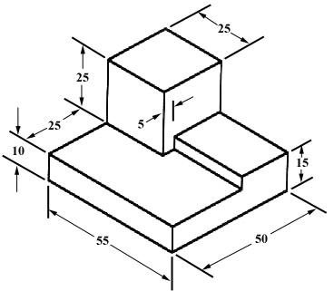

Isometric Drawing with Dimensions1

* For more information on how create isometric drawings visit  
  <http://www.me.umn.edu/courses/me2011/handouts/drawing/blanco-tutorial.html>

Orthographic View2

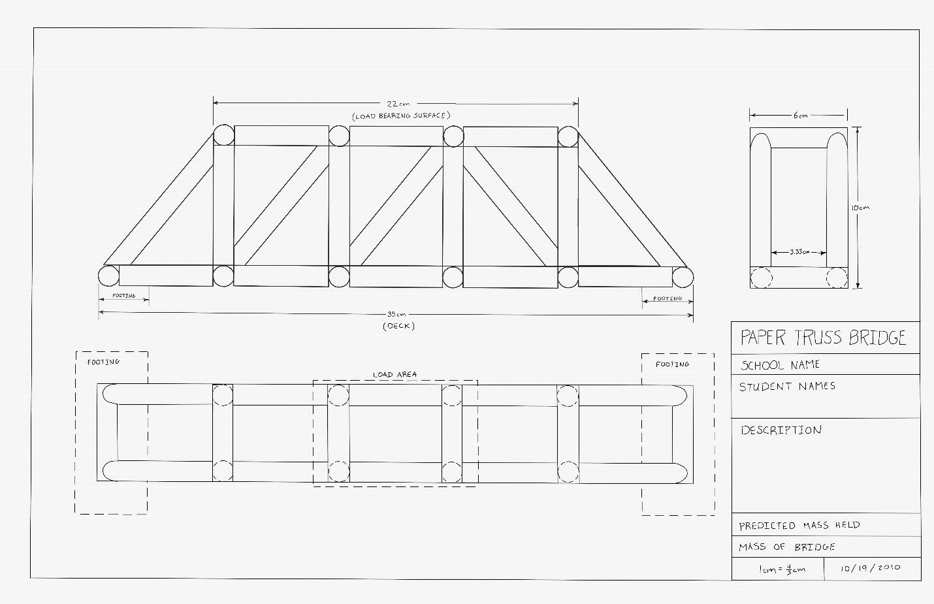

1. Blanco, Ernesto E., David G. Wilson, Sherodalyn Johnson, and LaTaunynia Flemings. "Engineering Drawing and Sketching." *Engineering Drawing and Sketching*. University of Minnesota Mechanical Engineering Department, n.d. Web. 25 July 2013. <http://www.me.umn.edu/courses/me2011/handouts/drawing/blanco-tutorial.html> .
2. Moriarty, Dylan. Paper Truss Bridge Drawing. Digital image. Arizona MESA, 26 Oct. 2010.

**Logic Diagram Sample.**

The logic shown demonstrates:

1. Configuring the Arduino input and output signals;
2. Driving the motor first in one direction for 10 seconds, and then reversing the motor direction for another ten seconds;
3. Turning the LED off and on during the running of the motor; and,
4. Exiting the program.

**Note: This is only a sample. Please research and use a diagram design that makes sense to you and be easy for others to follow**

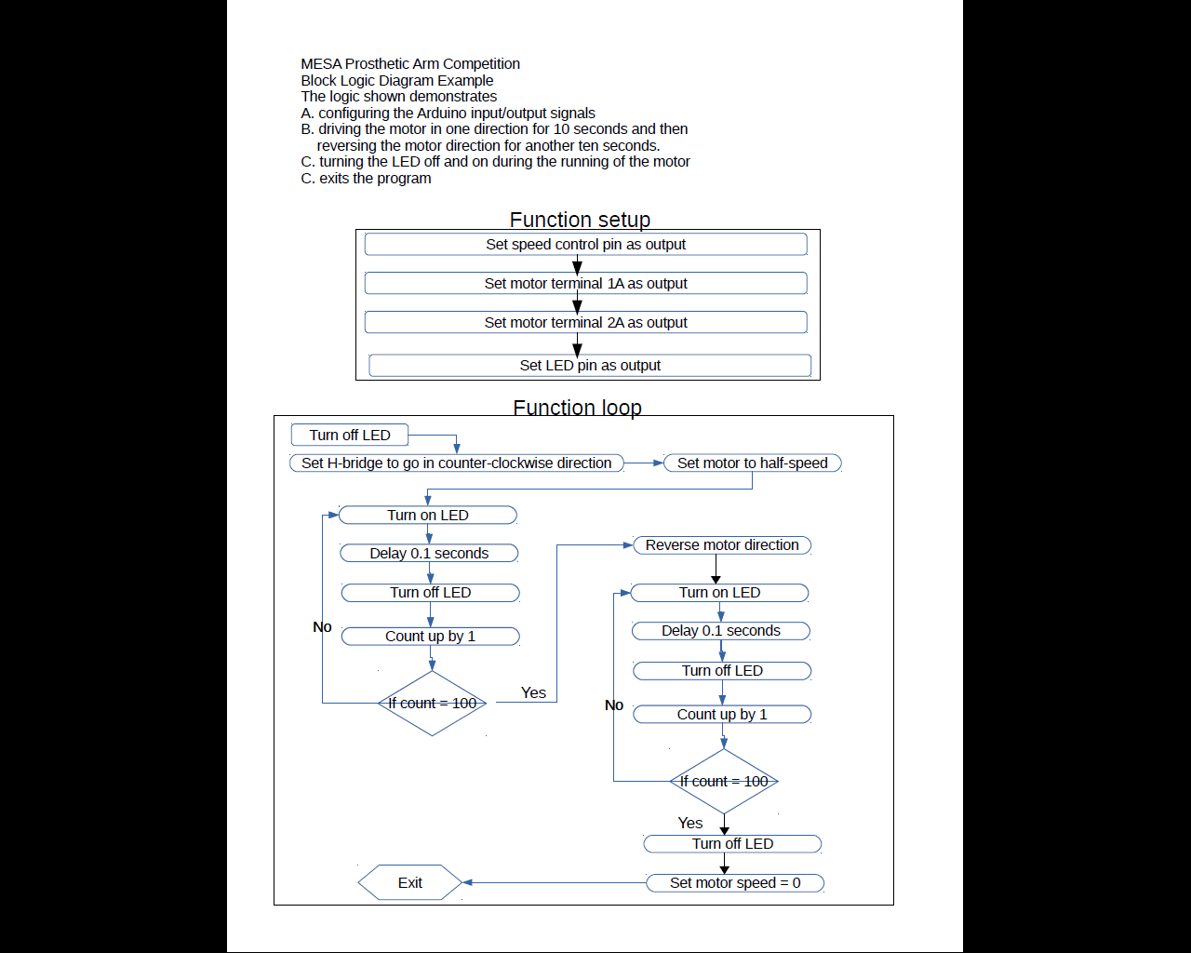

**Pseudocode Samples**

Pseudocode is an informal description of your programming logic. It should summarize and/or outline the program’s steps and should not contain any code syntax or underlying technology considerations. **Most importantly it should make sense to you and be easy for others to follow.**

Below are examples of what pseudocode could look like for the program described in the Block Diagram sample on page 11.

**Sample 1:**

The "setup" function:

Speed control is an output

Motor terminal "1A" is an output

Motor terminal "2A" is an output

LED pin is an output

Set motor_max_speed to 100*Note: maybe speed can take on a different value?*

The "main" function:

Turn LED OFF then:

Set H-bridge_dir to "counter-clockwise"

Set motor speed to (motor_max_speed) * 0.5 *Note: half of my max speed*

Set counter to 0

IF counter does not equal 100 THEN:

Turn on LED

pause for 0.1 seconds

Turn off LED

Add 1 to counter

OTHERWISE if counter equals 100:

*Note: whatever direction I’m in, go the opposite*

IF h-bridge_dir is set to "clockwise", set to "counter clockwise

OTHERWISE if its set to "counter clockwise", set it to "clockwise"

Set counter to 0

IF counter does not equal 100:

Turn on LED

pause for 0.1 seconds

Turn off LED

Add 1 to counter

OTHERWISE if counter equals 100:

Turn off LED

Turn off the motor

EXIT the program

**Sample 2:**

Set-Up Function

Speed control is an output. Motor terminal "1A" is an output. Motor terminal "2A" is an output

LED pin is an output. Set motor_max_speed to 100.*Note: maybe speed can take on a different value?*

Main Function

Turn LED OFF. Set H-bridge_dir to "counter-clockwise.” Set motor speed to (motor_max_speed) times 0.5 *Note: half of my max speed.* Set counter to 0. IF counter does not equal 100. Turn on LED. Pause for 0.1 seconds. Turn off LED. Add 1 to counter. OTHERWISE if counter equals 100. *Note: whatever direction I’m in, go the opposite.* IF h-bridge_dir is set to "clockwise", set to "counter clockwise. OTHERWISE if its set to "counter clockwise", set it to "clockwise." Set counter to 0. IF counter does not equal 100. Turn on LED. Pause for 0.1 seconds. Turn off LED. Add 1 to counter. OTHERWISE if counter equals 100. Turn off LED. Turn off the motor. EXIT the program.

**Specification Question Process:**

When asking for clarification on the National Competition Rules or for any other question about the National Competition the following process will be used:

* + - 1. Teams must contact their state representative via email (see the list below).*
      2. If possible, the state representative will respond via email. This question and the response will also be provided to other schools within that state.
      3. If necessary, the representative will contact the National Rules Committee to discuss the question. The committee’s decision will be relayed to all states for public distribution and the question will be listed on the national FAQ list on the MESA USA website ([MESAUSA.ORG](HTTP://MESAUSA.ORG)).

* Questions sent directly to the National Rules Committee will be rerouted to the state representative.

**State Representatives:**

* Arizona – Manny Leon ([leon@arizona.edu](mailto:leon@arizona.edu))
* California – Ben Louie ([blouie@usc.edu](mailto:blouie@usc.edu)) or Cathy Douglas ([cathyd@seas.ucla.edu](mailto:cathyd@seas.ucla.edu))
* Colorado – contact National Committee at [nationalcompetition@mesausa.org](mailto:nationalcompetition@mesausa.org)
* Illinois – Lauren Thompson ([lthomp21@csu.edu](mailto:lthomp21@csu.edu))
* Maryland – Jason Johsnon ([Jason.Johnson@jhuapl.edu](mailto:Jason.Johnson@jhuapl.edu))
* New Mexico – Anita Gonzales ([anita@nmmesa.org](mailto:anita@nmmesa.org))
* Oregon – Tamara Depue ([tdepue@cecs.pdx.edu](mailto:tdepue@cecs.pdx.edu))
* Pennsylvania – Spencer Thomas ([tuf35398@temple.edu](mailto:tuf35398@temple.edu)) or Gina Bloise ([tud52490@temple.edu](mailto:tud52490@temple.edu))
* Utah – Phil Gillaspy ([phgphd@yahoo.com](mailto:phgphd@yahoo.com))
* Washington – Curt Sande ([sande@wsu.edu](mailto:sande@wsu.edu))