`[Make your additions on all highlighted sections.]
ENGINEERING NOTEBOOK
2017

School:
Teacher:
Team Name:

Team Member Names:

Table of Contents

[Do this section last, type up your titles and match them to your page numbers.]
Example:
“Introduction Title”.................................................................................................Page 1

The Engineering Design Process

The engineering design process (EDP) is a cyclic model that is designed to help scientists and engineers build up ideas to turn them into real world projects. This process will help guide students to model their ideas and build their ideas into projects. Students will implement the engineering design process in the lab notebook.

Define the problem

What is needed to solve the problems?
Brainstorm solution
Sketch a design idea
Eliminate or add ideas to your sketch design
Prepare design requirements and conceptual drawings
Build models and component parts
Build a solution prototype
Test, evaluate, and revise
Communicate the solution
Identifying a Problem

Do you ever wonder about something, maybe how it works perhaps, your phone, the microwave, or your prosthetic arm? Begin with something that is close and personal to you. Think about what you have been learning in class.

Directions: Make a list of some problems you would like to solve with your prosthetic arm?
One way to do this is called “brainwriting”.

Write a list of “Criteria” and a list of “Constraints” in solving this problem?

Criteria Constraints

Activity Mapping Process

2. Activity: Explains what is involved in the activity
3. Post-Activity: Includes what is involved after the activity
4. Assessment: Involves how one knows if the activity has been successful
Pre-activity: Describes what is done before the activity

Let’s practice Activity Mapping in this example:
You and your friend are going on a trip.

- Prepare  (Pre-Activity) | Check weather  Make a list of items  Buy tickets  Book lodging  Wash clothes  Getting you identification | Preparation involves gathering all the information and item needed to pack your luggage completely.
2. Packing  (Activity) | Pack luggage  Get on plane, train, car (whichever mode of transportation) | Making sure that all your needed clothes and materials are in your luggage and on your way to your trip.
3. Unpacking  (Post-Activity) | Get to lodging  Put away clothing and toiletries  Store luggage | Checking in to lodging and putting away your clothes and materials.
4. Assessment | Did you pack for the right weather?  Did you bring all the items you needed? | Assessment allows you to determine whether
Directions: Choose a process (your prosthetic arm). Then describe the products involved in each of the process listed below.

Sketch |  | Pre-Activity
Design |  | Activity
Build |  | Post- Activity
Assessment |  | Assessment

- Are there any problems with the product, any suggestions for improving or inventing your new product?

- What could make life easier for people who design this product?

Research Problem

Before we begin practice writing the introduction, let us first understand the meaning of the background information.
Directions: Think of your prosthetic arm, you will begin with research.

Problem: What are some characteristics of current products? How will your design differ from another similar product?
Research the Problem:

Explore some ideas for solving the Problem:

Purpose: Why is it important to solve this problem?

Background: What is this project about?

Sources: Remember to cite all sites from where you got information

Introduction
In this section provide the date, purpose, and the background of the experiment.

1. Purpose. In your own words, provide a compelling overview of your team’s design purpose or motivation (e.g., to solve a problem, to address a particular need, to evaluate or introduce a new concept etc.).

2. Scope. Provide a clear restatement, in your own words, of the design problem including success criteria, limiting factors/constraints, and key variables to consider. After overviewing the design problem, make sure to overview your investigation approach and your design method.

3. Background Information. Present facts the reader should know, conditions or events prior to the project and any details of previous reports. This should include the research you have done- your review of other investigators/designers, as well as any of your related design objectives or hypotheses.

Developing a Hypothesis
This section will help you understand the purpose of your project. You now have some background information about the problem reflected in your project. You will not develop your hypothesis. A hypothesis is a testable statement/prediction. The testable prediction is written as if and then format.

Let us first think what we would like to examine and then make a prediction.
Examine:
The lightweightness of our Prosthetic Arm (or other characteristic or feature of your arm)

Example:
Prosthetic Arm-
If my Arm has four “fingers” then it will be able to pick up more items for the challenge.

Directions- Think of what you want to test your product, then write a few hypotheses.
Hypothesis Draft 1

Hypothesis Draft 2

Hypothesis Draft 3

Identifying Your Variables
Before we move on to the materials section, let us figure out what we are testing. First let’s start by identifying the variables.

In a controlled experiment there are two types of variables:
- The manipulated or independent variables is the one you will change or manipulate.
- The dependent variable is the one that responds to the changes you make in your testing.
When writing your hypothesis (if and then statement) the variables are as follow:
If is followed by the manipulated variable...then is followed by the responding variable.

Example
Step 1: Identify the manipulated variable
Example for Arm: The type of material used to create the “fingers” or “claw”
Step 2: Identify the dependent variable in your investigation
Example for Arm: The number of tasks your Arm is able to accomplish
Hypothesis: If the Arm’s “claw” is made out of plywood then it will accomplish a more tasks.

Another way to identify your variables is by visualizing it with a sketch

Independent
Variable
Dependent
Variable
Type of material
Background questions
How will the type of material affect the tasks?

How is my design affected by the this material?
Quantitative observations
How much does your arm weigh?
How many tasks can my Arm do?
How much material was used?
Qualitative observations
How does your Arm look?
How does it feel when you wear it to do the tasks?

Identify Variables for________________________(your product)
It is time to write your variables. Think of the following questions:
- What background information do you need about the independent variable?
- What qualitative and quantitative observations will you collect on the dependent variable?

*You can do a sketch (like the sample in page 9 or list your variables.

- List your independent (manipulated) variables
1.

2.

3.

B. List your dependent (responding) variables
1.

2.

3.
C. Observations

Quantitative:

Qualitative:

Materials

List the materials you are using for your Prosthetic Arm (Keep track of the costs on your Budget Sheet).
Note: List the materials without numbers. This is the proper format.

Why are you using these materials?

Procedure
Now that we have our materials and we know what we want to test for, we can write a procedure.

A procedure is a written plan that describes the steps that are needed to conduct the controlled experiment it is sometimes called the methods section. It is written as if someone was being given directions.

Example
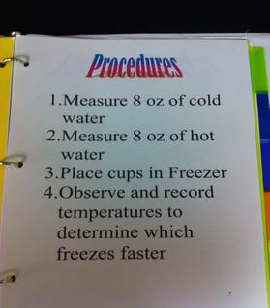
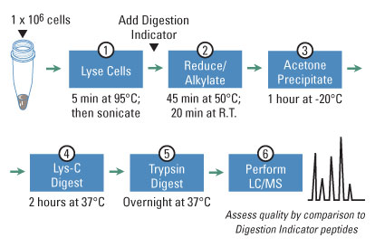
List-

Diagram/Pictorial Form-
Your Procedure
Write the procedure you will need to conduct your experiment (testing). Write this as if you were giving step by step directions to someone.

In order to test your hypothesis, what methods does your team need?

Note that your procedure needs to be numbered.

Practice to Draw Sketch
It is good to have a sketch of the design so improvements can be made throughout the design process.

Example: Scientific Illustration sketching a pencil
When doing a sketch it is best to label the parts of your drawing. This helps others working in that project to know what materials you need.
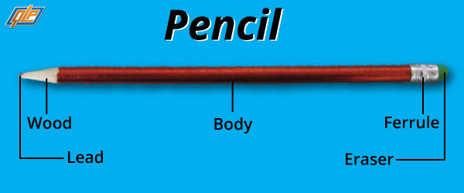
Directions: Your turn, sketch your Arm:

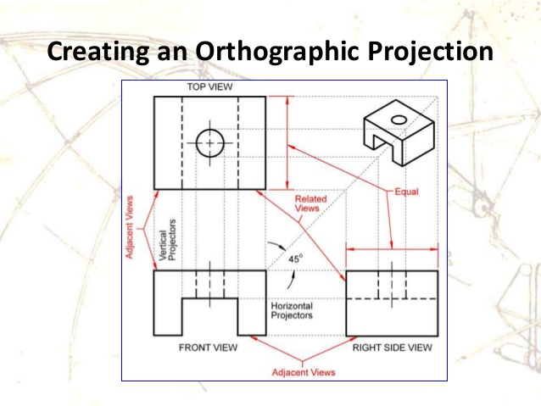
(Prosthetic Arm Only) Orthographic Drawing
Directions: Try doing your Prosthetic Arm Orthographic drawing.

Making Observations
You have completed your practice sketches, now practice to make observations of physical characteristics. As an engineer, you must make careful observations and record these as you design, build, and test your product. These observations become your Qualitative Data.
Directions: Fill in with your own qualitative observations.

Think of properties you can see such as: size, shape, texture, behavior, color, smell, other... | I see…  I feel...
Think of other properties such as sound and touch | I hear…  I smell...
Connect this to something you already know | It reminds me of…
Add more detail as needed | This is so because...
Be curious and ask more questions you might investigate | I am curious about…  It surprises me that…  I wonder what would happen if...

Testing Data Collection
Once you begin testing your Prosthetic Arm, keep track of your testing by collecting data at each trial.
Directions: Test your product and collect data. If you need more space add more tables of your own. *Ok to customize your own table.

Trial | Observations | Time | Results
1
2
3
4
5
6
7

Data Analysis
Now that you have a data table, convert that data into a visual representation . A graph should have a title, x-axis, and y-axis. Make sure to label your graph.
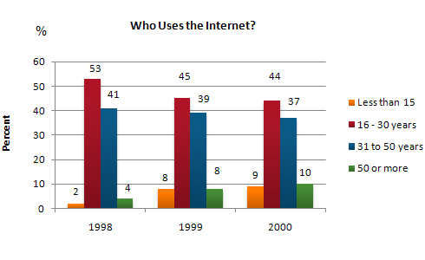
Sample:

Describe the patterns in your data

Archiving Your Work
Take pictures of your team and your work, from start to finish. You can place them here: date and label them.

Organizing Your Results
Now that you have your data, it is time to organize your results based on your data.
Directions: Answer the main question is: What are the similarities and differences you observed?

Writing up the Results
Now that you organized your results it is time to write about them. This means describing in words what the data means.
Compare and contrast is one way of writing up the results from your data.

Start with how your Prosthetic Arm Testings or Simulation Testings are similar from your observations and research
Add more details as needed from your data charts
Explain how the results are different using the evidence from your data charts.

Use terms such as:
But…
Yet…
Despite…
In spite of…
Although...
Whereas..
However…
Nevertheless…
In contrast…
In comparison…
On the other hand...
To contrast the two

Add more detail from your charts as needed

Discussion
You will now interpret the data and determine whether or not your hypothesis was accepted. You can discuss any mistakes you might have made while conducting the investigation. You may wish to describe ways your project might have been improved.

Explain technical content: Briefly summarize any particular STEM (Science, Technology, Engineering, and Math) concepts that most informed your team’s design process for your Prosthetic Arml.

Go the Extra Mile: Clearly describe any extra measures your team made to have a superb Prosthetic Arm?

Acknowledgement
Use this space to show appreciation by recognizing and thanking the people who helped you to complete this project. These are people such as your teachers, parents, team members, or anybody else who helped you with your project.

In this section it is important to let your reader know that you have sought and received help in completing your work.

Cost Labor Summary
Include a detailed table reflecting student time commitment as well as volunteer support. Every Time somebody works on your project, be sure to record this information in the table below:

Date | Name of person | How much time did you work on the project? | What did you work on?

Creating a Reference Page

Sample:

Creating Reference Page (APA)
Reference from a book.  (One author) | Gorman, Elizabeth, Prairie Women. New Haven: Yale University Press, 1986.
Reference from a book.  (Two authors) | Caper, Charles and Lawrence T. Teamos. How to Camp. Philadelphia: Doubleday, 1986.
Reference from a  Journal | Doe, John. “The Evolution of Media.” Pennsylvania Daily 72.4 (2006): 96-100.
Newspaper Article | Achenbach, Joel. “America’s river.” Washington Post. 5 May 2002. 20 July 2003. Retrieved from  http;//www.washingtonpost.com/wp-dyn/ articles/  A13425-2202May1.html
Reference from an  internet website. | Benson, David. Ankle Replacement Prosthetics. 16  Nov. 2007. University of Maryland. 6 Feb. 2008.  Retrieved from http//www.anklerplacment.com
Television or radio | “Karma Chameleon.” Northern Exposure. CBS. KCRA,  Sacramento. 29. 2000.

For more information about the citation format refer to
http://owl.english.purdue.edu/media/pdf/20110928111055_949.pdf

*Remember to include all your resources.

Writing your reference Page
Directions: Use the last name of the author to arrange yours sources in alphabetical order.

Other Notes
Include other notes that don’t fit into other categories in here. All your ideas are very important, so record all of them.

